**Experiment 1.2**

**Student Name:   Gaurav Kumar                                UID: 22MCC20177**

**Branch:   CC-DevOps                                                        Section/Group: 1/B**

**Semester:   I                                                               Date of Performance: 14/11/2022**

**Subject Name:** **Linux Administration Lab Subject Code: 22CAP-648**

1. **Write a command used to display existing partitions and sizes using 2 different commands. After than compare the outputs of both. After this create a new 400MB primary partition and 2 extended partition under that primary partition and check whether both partitions are created or not.**
2. 1. Open Linux terminal
3. 2. Write fdisk –l to view the partitions
4. 3. Select the partition using fdisk /dev/sda1
5. 4. Disk Partitions displayed with details
6. We can also view Disk partitions using lsblk. it displays block devices, when used with the -f option, it
7. prints file system type on partitions as well
8. now Creating primary partition and 2 extended partitions

**Ans :**

1. Open Terminal
2. Write fdisk –l to view list of partition

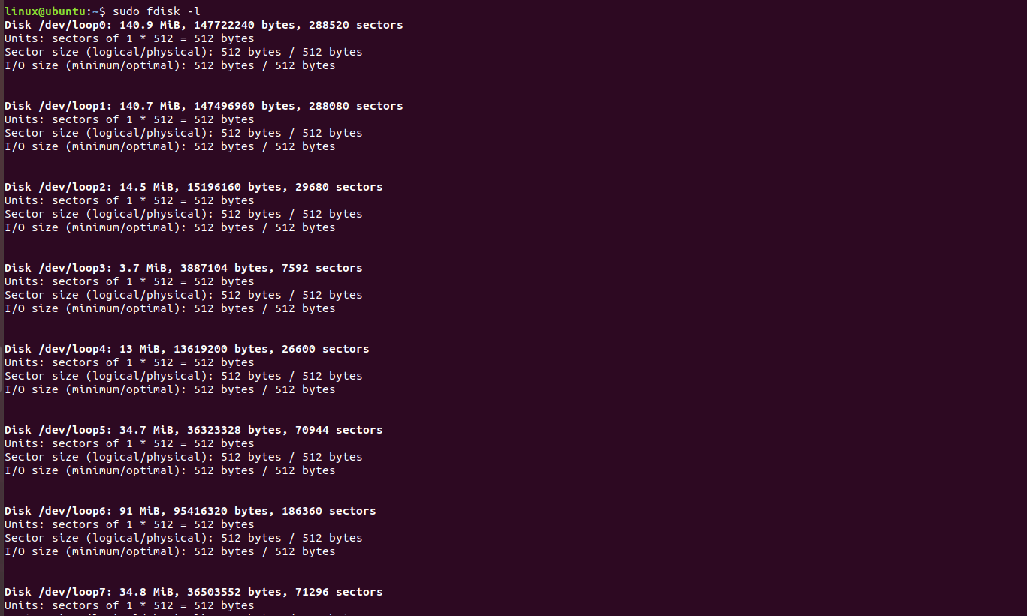

1. We can also use lsblk

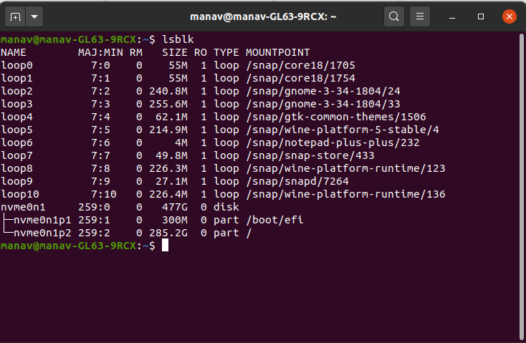

1. Select the partition using fdisk /dev/sda1

We can also view Disk partitions using Isblk. it displays block devices, when used with the -f option, it prints file system type on partitions as well now Creating primary partition and 2 extended partitions

1. Verify the partitions available on the server: fdisk –l
2. Choose which device you wish to use (such as /dev/sda or /dev/sdb)
3. Run fdisk /dev/sdX (where X is the device you would like to add the partition to)
4. Type 'n' to create a new partition.
5. Specify where you would like the partition to end and staff You can set the number of NIB
6. of the partition instead of the end cylinder. For example: 400M
7. Type 'p' to view the partition, and type 'w' to save the partition
8. **Learning outcomes (What I have learnt):** 
   * 1. **About fdisk and lsblk**
     2. **About disk partition**
     3. **Learn to create a new partition**

**Evaluation Grid:**

|  |  |  |  |
| --- | --- | --- | --- |
| Sr. No. | Parameters | Marks Obtained | Maximum Marks |
| 1. | Demonstration and Performance  (Quiz) |  | 22 |
| 2. | Worksheet |  | 8 |